Hindi Vidya Prachar Samiti’s
RAMNIRANJAN JHUNJHUNWALA COLLEGE OF ARTS, SCIENCE, AND COMMERCE
(EMPOWERED AUTONOMOUS)

Optimization Technique
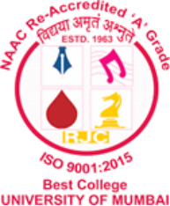

Name: Surajkumar Yadav
Roll no: 10404
Class: MSc. Data Science and Artificial Intelligence Part II
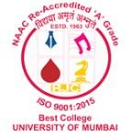
Ramniranjan Jhunjhunwala College
of Arts, Science and Commerce

Department of Data Science and Artificial Intelligence

CERTIFICATE

This is to certify that Surajkumar Yadav of MSc. Data Science and Artificial Intelligence Roll No. 10404 has successfully completed the practical’s of Optimization Technique during the Academic Year 2025-2026.
Date:

(Prof. Rahul Yadav) External Examiner
Prof-In-Charge

